Re-Application of Cash/Memo
- Go to menu option A-C-5 (Apply/Reapply Cash/Memos)

- Type in the Customer# and check# at top of the screen. Make sure you click the posted toggle box.
  - Click the Go button and the check will populate on the screen.
  - Highlight the line item you want to move to another invoice and click the Apply/Reapply Tab to view the cash receipt. You will get a pop-up asking (Do you wish to reapply this check/memo?). Click YES

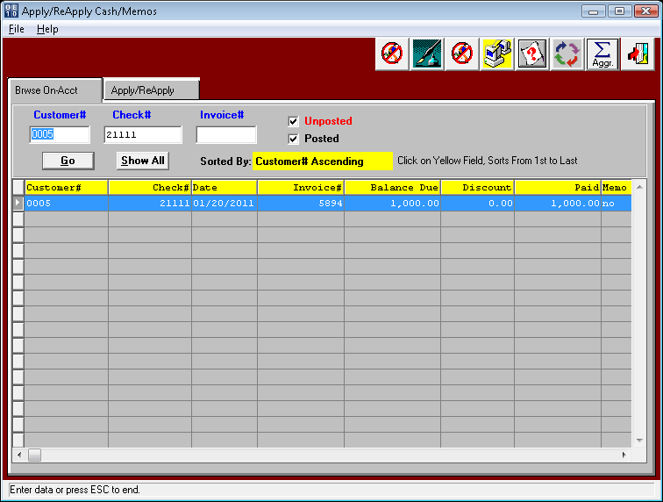
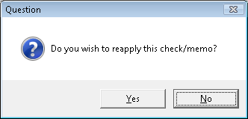

- Highlight the line item to be changed and click the update button on the bottom.
- Type in or use your F1 function key to change the invoice number.
- Run the A-C-6 (Edit/Post Applied Items) to post the entry.

